**Create VPC private, public subnet & IGW, NAT Gateway:**

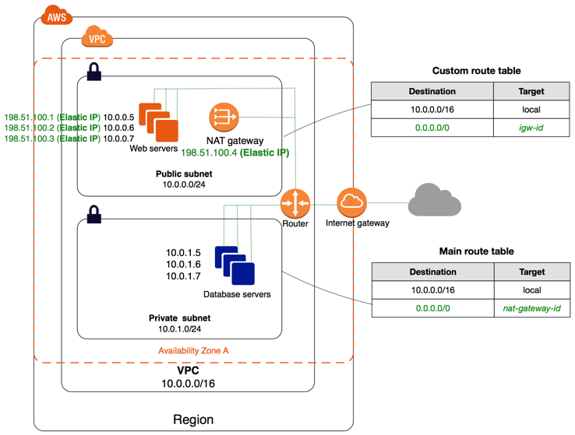

**Steps for Create private, public, IGW, NAT Gateway:**

**Step1: Create VPC**

Open console – VPC (services) – Create VPC – VPC Only – Name Tag (MY-VPC) – Ipv4 CIDR – 10.0.0.0/16 – Create VPC**.**

**Step 2: Create Public Subnet**

Click on Subnets – Create Subnet – VPC-ID – (MY-VPC) – Subnet Name – (public-subnet01) – Availability Zone – (select 1st zone) – Ipv4 CIDR Block (10.0.0.0/24) –Create Subnet.

**Step 3: Create Private Subnet**

Click on Subnets – Create Subnet – VPC-ID – (MY-VPC) – Subnet Name – (private-subnet02) – Availability Zone – (select 1st zone) – Ipv4 CIDR Block (10.0.1.0/24) –Create Subnet.

**Step 4: Create IGW**

Click on Internet Gateways – Create Internet Gateway – Name Tag (my-internet-gateway – create Internet gateway – Action – Attach to VPC – Available VPC’s (MY-VPC) – Attach Internet Gateway.

**Step 5: Routing Tables for public-subnet01**

Click on Route Tables – Create Route Table – Name (public-routing) – VPC (MY-VPC) –create route table - Subnet associations – edit subnet associations – select public-subnet01 – save association – routes – edit routes – add route – 0.0.0.0/0 – select internet gateway – save changes

**Step 6: Routing Tables for private-subnet02**

Click on Route Tables – Create Route Table – Name (private-routing) – VPC (MY-VPC) - create route table - Subnet associations – edit subnet associations - select private-subnet02 – save association

**Step 7: Create EC2 Instance – for private**

Services - EC2 – Launch Instance –Name and tags ( private-server1)- Amazon Linux 2 AMI (Free tier eligible) – Network Settings – edit – VPC (MY-VPC) – Subnet – private-subnet02 – Launch Instance

**Step 8: Create EC2 Instance – for public**

Services - EC2 – Launch Instance –Name and tags ( ppublic-server1)- Amazon Linux 2 AMI (Free tier eligible) – Network Settings – edit – VPC (MY-VPC) – Subnet – public-subnet01 – Auto-assign public IP – Enable - Launch Instance

**Step 9: Launch EC2 Instance-**

**Create 2 Windows server one in private and one in public network.**

Connect public server using remote desktop – check internet working or not – connect private server through public server ( by using remote desktop connection) check internet working or not in private server – for internet connectivity required NAT Gateway ( create in following step)

**Step10 – Create NAT Gateway**

Service – VPC – NAT Gateway – Create NAT Gateway – (my-natgateway) – Subnet – public-subnet01 – Elastic IP allocation ID – Allocate Elastic IP – create NAT Gateway.

VPC – Route Table – Private-routing – route – edit routes – add route – 0.0.0.0/0 select Nat gateway (my-natgateway) –save changes.

**Step11 – Check private subnet instance internet connectivity**

Access private instance via public instance – try to ping google or other internet services.